08.11.2021г. группа 1ТМ 1 пара
Дисциплина ОДБ.03 Иностранный язык
Преподаватель Романюта Маргарита Вадимовна
Занятие № 16
Модуль 5 «HOLIDAYS»
Тема 5.1. Проблемы на отдыхе. Река Темза.
Цели:
• Образовательная – расширение эрудиции студентов, их общего и лингвистического кругозора на основе практического овладения английским языком;
• Практическая–
1. Развитие навыков чтения, устной речи.
2. Совершенствование коммуникативно-познавательной компетенции студентов по теме «».
• Развивающая – развитие языковых, интеллектуальных и познавательных способностей студентов.
• Воспитательная – воспитание у студентов уважительного отношения к окружающей среде.
1.Работа с лексикой
1.1.Прочитайте слова в словаре WL 14-15 к занятию 5а.
1.2.Запишите в тетрадь слова с транскрипцией.
2.Работа с текстом на стр. 82.
2.1. Read and translate the text «Beautiful Nepal! ».
Sun 5th April - Kathmandu
We arrived safely in a very foggy Kathmandu after our short but delayed flight from India. We caught a local bus to the hotel, passing street vendors, beggars, shoeshine boys and even a barber with his chair and cracked mirror out on the pavement! This morning we escaped the dust, noise and pollution of the city to visit the incredible Monkey Temple up in the hills. There really were hundreds of monkeys there — they were running around everywhere. There were lots of steps to climb but it was worth it — the view of the snowy peaks of the Himalayas in the distance was absolutely breathtaking!
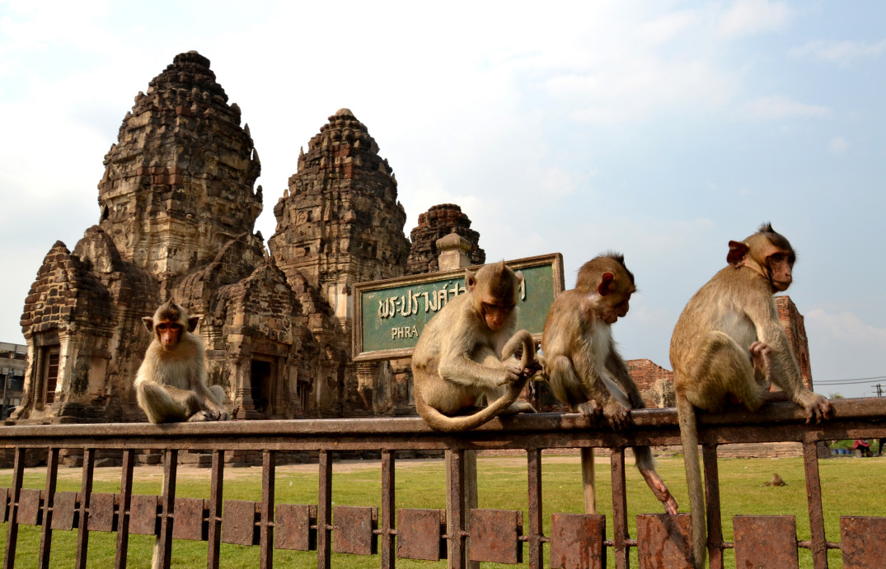
Tues 7th April - The Himalayas
We woke up yesterday morning feeling so excited! Finally the day we would begin our 2-day trekking excursion to the Himalayas had arrived! We took a small plane journey from Kathmandu and then trekked for hours up and down the rocky mountain trail. It was hot in the bright mountain sun but quite cold wherever there was some shade. You can't imagine how spectacular the scenery was! We finally reached a village called Phakding where we put up our tent and camped outside a teahouse. We tried some local dishes, which were delicious, and then got into our sleeping bags. It got cold very quickly once the sun had gone down! I awoke the next morning to the most amazing sunrise I had ever seen! I took a walk down
to the river where I ran into two young boys playing. They were really friendly. Nepalese villages are very poor, but everyone we met in the mountains seemed happy.
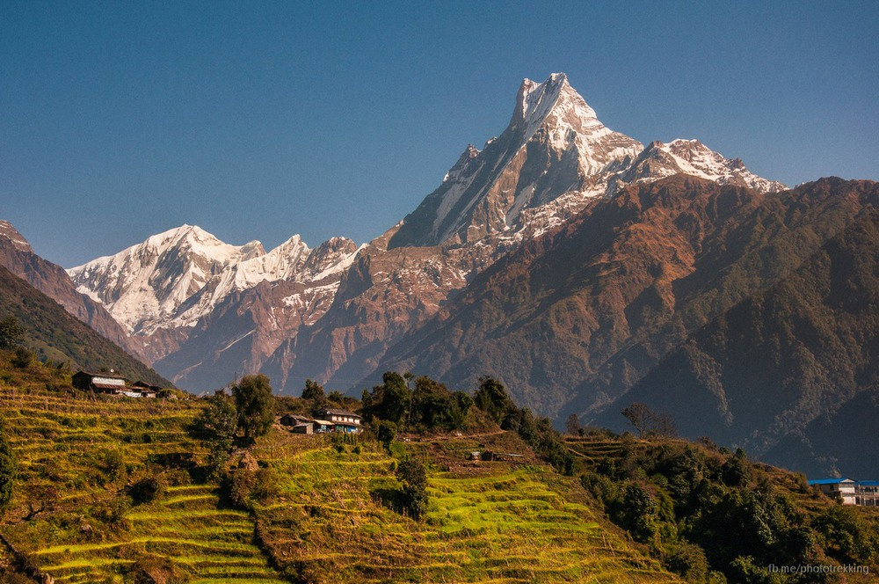
Thurs 9th April - Bhaktapur
Returning from the mountains, Kathmandu seemed even busier than when we left! We took a taxi to the ancient town of Bhaktapur today as we had heard that its annual festival Bisket Jatra was taking place. When we got there, we hired a guide, who took us to see the noisy tug-of-war contest that kicks off the festival every year. Apparently, the festival is based on a fairy tale and continues for days. It includes a wild parade, a candlelit procession and two more tugs-of-war! Later in the day, we went on a guided tour of Bhaktapur's magnificent temples, then we went shopping for souvenirs. The city is full of craftsmen selling paintings and handicrafts. I bought some beautiful pottery and Jake found a fantastic pair of hand-made drums!
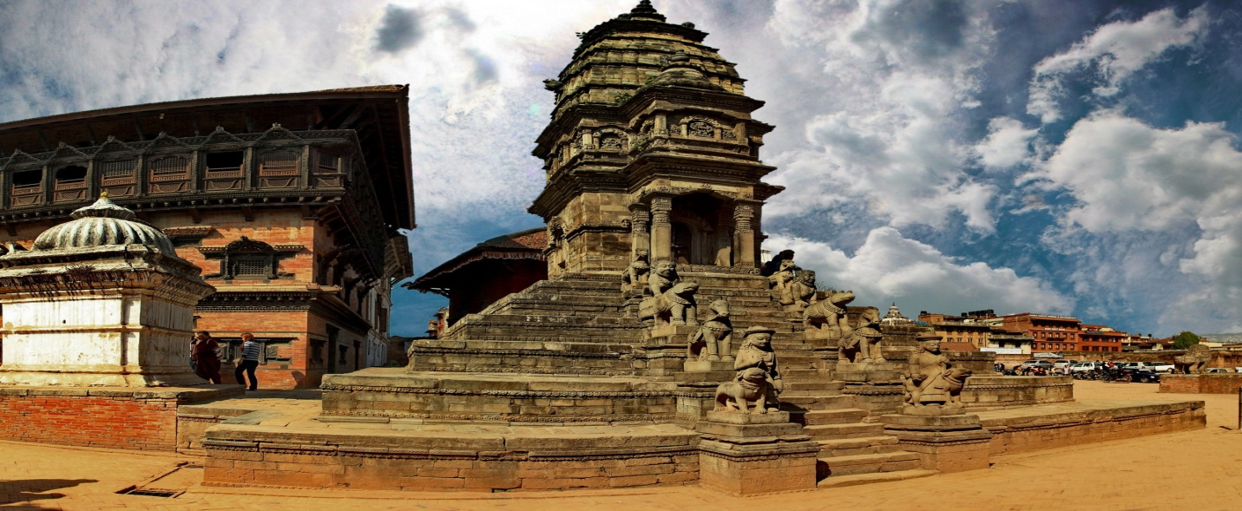
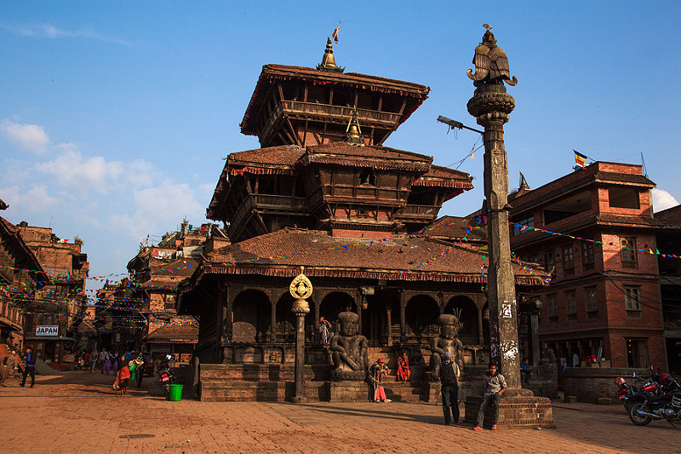
Sat 11th April - Home Sweet Home!
Jake and I finally put on our backpacks for the last time and flew home today after 5 weeks, 4 countries, 2 nasty viruses and countless temples, mountains, beaches and cheap campsites and hotels! I'll never forget the amazing experiences I've had backpacking through Asia, but right now I'm looking forward to some home comforts and a good night's sleep...
2.2. Answer the questions:
1. What was the weather like in Kathmandu? The Himalayas?
2. What means of transport did they use while in Nepal?
3. Where did they stay?
4. What did they do and see in each place?

3 .Работа с лексикой
1.1.Прочитайте слова в словаре WL 16 -17 к занятию “Culture corner 5”.
1.2.Запишите в тетрадь слова с транскрипцией.
4.Работа с текстом на стр. 95.
4.1. Read and translate the text “Take a Trip along the Thames”. Complete the gaps (1-8) with the correct words derived from the words in brackets.
The London Eye
Would you like to get a bird's eye view of London, as well as having the experience of a lifetime? If so, take a 1) ….. (thrill) ride on the London Eye, the big wheel built in 2000 for the millennium.
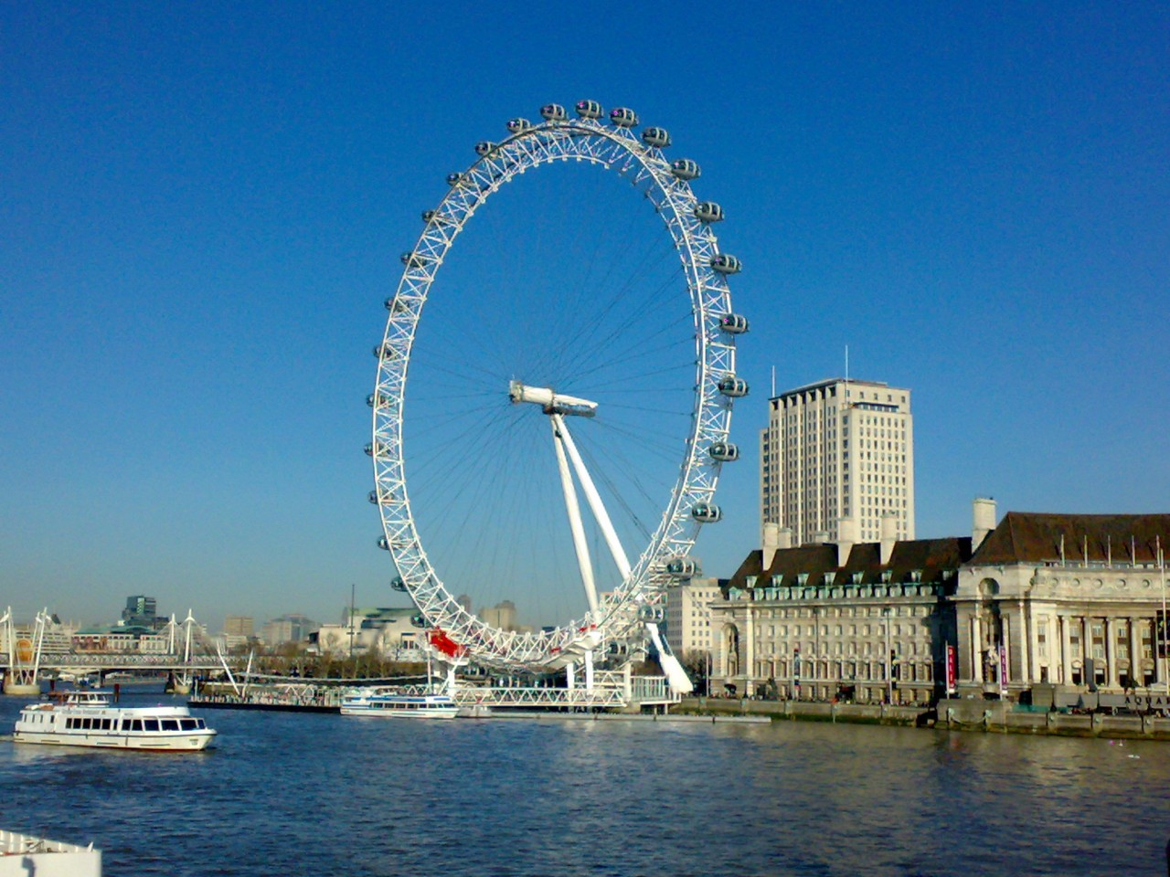
The Tower of London
The Tower has served many purposes in the past. It has been a prison, a medieval palace, a fortress and an arsenal. It's an 2) ….. (amazе) place to visit! You can see the incredible Crown Jewels and the 3) ….. (famе) Beefeaters in their 4) …… (usual) costumes.
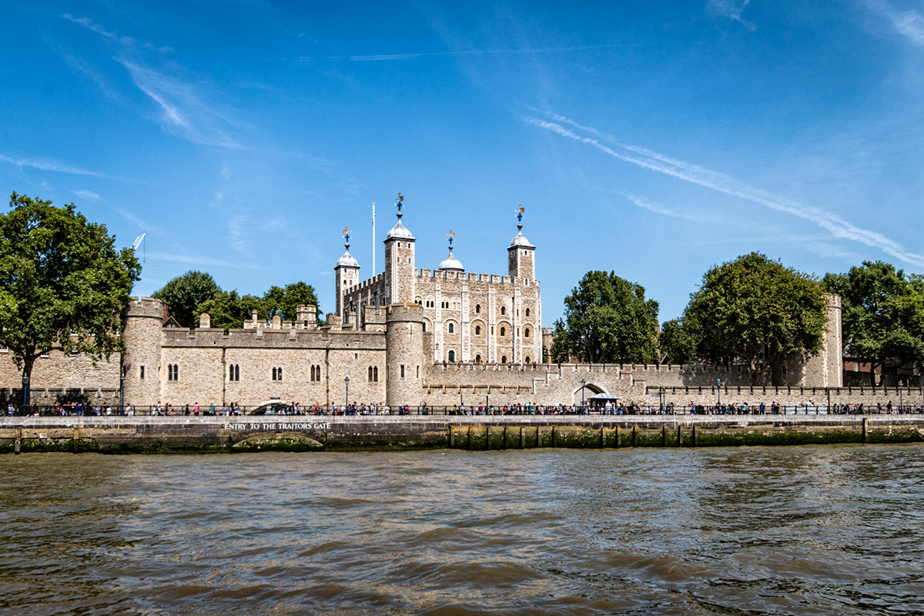
The London Dungeon
If you like to be scared out of your wits, this is the place for you! Go deep underground and learn about the Great Fire of London, Jack the Ripper and The Great Plague. You can also try to get out of a scary labyrinth of mirrors. Not an experience for the faint-hearted, but you will 5) …..(thorough) enjoy telling your friends about it.
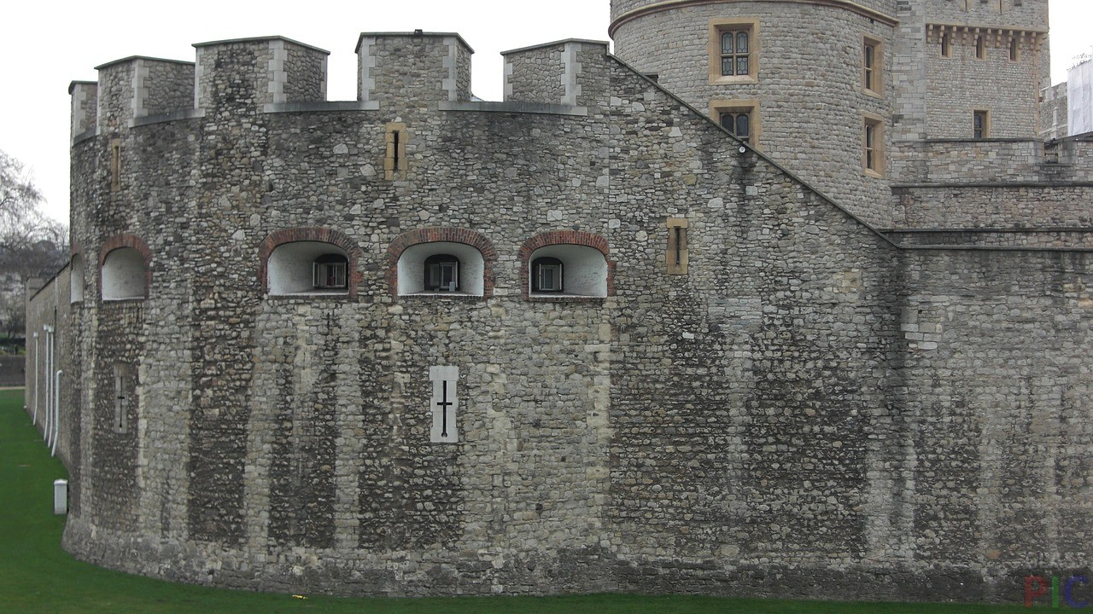
Shakespeare's Globe Theatre
The original Globe Theatre burnt down in a fire started by a cannon which was fired during a 6) …..(perform). The most recent Globe, which was completed in 1997, isn't just a theatre. It runs 7) …..( education) workshops and lectures for schools and there's a permanent 8) …… (exhibit) showing visitors what the theatre was like in Shakespeare's time.
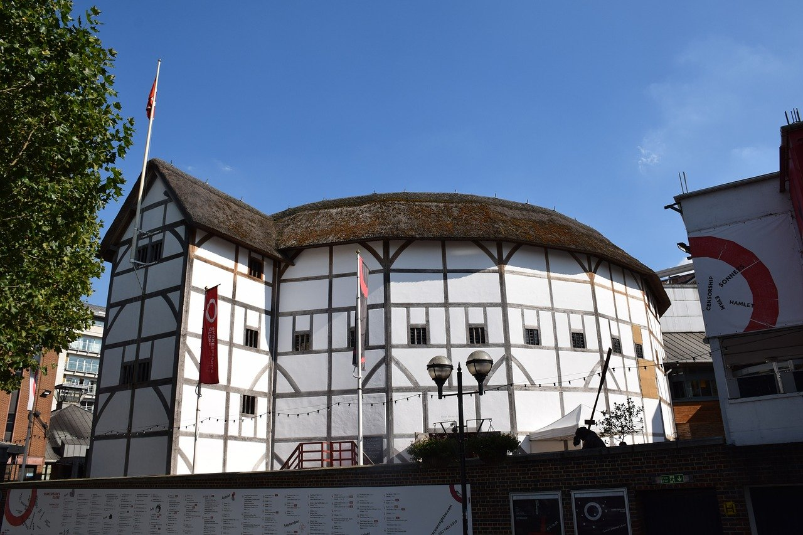
5. Грамматическое упражнение по теме « Past Simple and Past Continuous»
5.1. Put the verbs into the past simple or the past continuous:
1. A: Where ….. (you/be) last week?
В: I …… (relax) on the beach most of the week, actually.
2. A: Have you ever been to India?
B: Yes, I ….. (go) there last summer.
3. A: Why ….. ( you/ not/ come) last night?
B: Because I …. (study) for my exams.
4. A: How …. (be) your holiday?
B: Awful! It …. ( rain) the whole time.
5. A: How did you meet?
B: When we ….. ( walk) along the beach.
6. A: Where ….. (they/ spend) their last holiday?
B: They ….. (want) to go to Spain but in the end they ..... (decide) on China.
Домашнее задание:
1.Письменно выполнить упражнение 2.2. и 5.1. данного занятия.
2.Написать и перевести образованные слова при чтении текста “Take a Trip along the Thames” в упр. 4.1.
Срок выполнения задания до 10.11.2021.
Все работы выполнять в рабочих тетрадях, фотографировать и отправлять на адрес преподавателя Романюты М.В. rita.romanyuta@mail.ru
Используемая литература:
1. Афанасьева О.В., Дули Дж., Михеева И.В., Оби Б., Эванс В. УМК «Английский в фокусе» для 10 класса, М.: Просвещение; UK.: Express Publishing: 2018;
2. Агабекян И. П., Коваленко П. И. Английский для технических вузов. Феникс, Ростов-на/Д, 2009.
Дополнительные источники:
- Ионина И., Саакян А. Английская грамматика. Теория и практика. – М.: Академия, 2008.
- Бережная О. О. Сборник новых тем современного английского языка. Донецк, 2009.
Справочники:
- Мюллер В. К. Англо-русский и русско-английский словарь. – М.: ЭКСМО, 2010.
Интернет-ресурсы:
- Портал по изучению английского языка.
Форма доступа: http//www.englishlanguage.ru.
- Сайты для изучения английского языка.
Форма доступа: http://www. study.ru – English Info
http://www.native-english.ru
http://www.study.ru
http://www.homeenglish.ru

